Drug Analyser

Praveen Surapaneni, Uma Mahesh Kothuri, Lakshmana Dheeraj Polisetty,

Vinod Kumar Vakalapudi, Venkata Reddy Guttikonda, James Dowling

Department Of CSEE,

University of Missouri Kansas City.

Abstract—Artificial Intelligence has explored into many ways in this modern era. Mobile Doctor is a Q&A system that effectively gives us the side effects of a particular Drug.

1. Introduction

Our Applications is a suggestion algorithm where we will be suggesting the user about the particular drug’s effectiveness based on the health conditions he faced during his life and, In addition to that our algorithm will rate all the available drugs for the particular health condition and suggest them to the user.

Our App is somewhat similar to Watson User modelling Demo where a HR based on requirement searches for a developer and the HR gets all the suggestions in the percentage model and here in our APP users searches a drug for a particular health condition he is facing right now our App will suggest all the drugs based on their effectiveness score given by our algorithm..

1. Architecture

Initially this application will be containing a screen that will have all the diseases listed. Out of this disease list the user can select the health conditions he faced in his life. This will help the application to understand about the Users Health Condition. Once the users data is entered it will saved with the App, Now whenever User asks updates the application with any new disease and the drug he is going to use ,the application will let the user about the effectiveness of the drug on his/her body.

This Android application primarily contains three steps. The first phase will be a screen where the end-user will be selecting a disease and drug combination he want to use. This screen has a list of almost all the diseases the humans are known of. The second step is storing the user entered data into a Database.

The Third phase contains of processing the User entered data. To this we have used certain services which will described in the next paras for retrieving the details of disease and drugs. This step also contains an algorithm that will give the effectiveness of a particular disease-drug combination to the user.

1. Improvements for Third Iteration

We have partially implemented voice based actions where every feature of our application can be accessed using voice. We are facing many problems to detect many health conditions and drugs and we are trying to improve the voice recognition. We have improved the responsiveness of UI in the entire App and made some visual changes.

1. Services Used

To get the medicines information and other details we had used certain services in our application.

1. Adverse Effects

We will be getting all the previous health conditions reported after using a particular drug and for getting all these conditions we will be using a service provided by openFda which basically returns all the diseases associated with a particular drug in JSON format.

End Point: [https://api.fda.gov/drug/event.json Title and Author Details](https://api.fda.gov/drug/event.json%20Title%20and%20Author%20Details)

1. DRUG LABEL

There will be always side effects which will be listed on the label of the drug. We will be using this info to warn the user about potential side effects. For getting this info we will again be hitting openFda databases using RESTful services provided by them. End Point: <https://open.fda.gov/drug/label/reference/>

1. MEDICINES

In our application we will be suggesting user about all the available drugs for the health condition. For getting all the medicines for any health condition we will be using info from Drugs.com website. Duhs.com is not providing any RESTful or SOAP based services and no other websites are providing the medicines with such high quality. So Drugs.com left us no option but to scrap the data from their website.

1. Speech to Text:

We are thinking about implementing everything with voice based controls which requires very minimal or no touch based interactions from the user. For implementing that we have to use either google vice API or Speech to text based API from Watson services.

1. Conclusion

This application lets the users to choose the Drug side effects efficiently and there are certain chances of improvements. One of such improvement that can be done is listed below.

Right now in our application user has to enter all the medical conditions he ever faced and the medical conditions he is facing right now, this is a tedious procedure when you consider that user is already facing some kind of health condition, So we want implement an app which will be completely voice based and will be super fun to use. For that we will be using speech to text api and we have to understand the text from this api and parse it using tools provided by openNLP, Text runner and many other language processing APIs. Causal Productions permits the distribution and revision of these templates on the condition that Causal Productions is credited in the revised template as follows: “original version of this template was provided by courtesy of Causal Productions ([www.causalproductions.com)](http://www.causalproductions.com))”.

**Project Management**

Back End and Open FDA: Praveen Kumar Surapaneni (21), Vinod Kumar Vakalapudi (23)

Android UI: Uma Maheshwararao Kothuri (17), Venkat Guttikonda (13)

Watson Services: Dheeraj Polisetty(19), James Dowling.

**GitHub URL**

https://github.com/surapanenipraveen52/Project-Report-2

Screen Shots

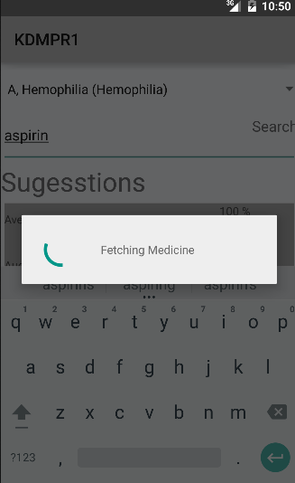

References

1. http://www.ibm.com/smarterplanet/us/en/ibmwatson/developercloud/services-catalog.html
2. <https://opennlp.apache.org/>
3. <https://opennlp.apache.org/documentation/1.5.3/manual/opennlp.html>
4. <https://homes.cs.washington.edu/~soderlan/OpenIE-ijcai07.pdf>
5. <https://code.google.com/p/newsterp/wiki/TextRunner>
6. <https://www.coursera.org/course/ml>

